Disability & Inclusion

One Page Summary
“The UK has achieved a great deal and has been at the forefront of developments in equality and disability rights. But we are clear that more needs to be done. We will continuously develop and deliver real and practical improvements to ensure disabled people have the same opportunities for inclusion as people who are not disabled.” (Sarah Newton MP, Minister for Disabled People, Health and Work, 3 October 2018)
Disability & Inclusion
Last year, the CPF considered the nature of Conservatism and Conservative values. One group noted that we need to “communicate our conservative mission in order for every person to recognise something of what they can achieve when barriers are removed.”
The vision of Conservatism that most resonated with members was that of One Nation Conservatism. Together, we defined this as “An inclusive, classless conservatism that embraces the needs, contributions and shared obligations of all communities in every region of the UK, promoting social integration, inter-generational solidarity and an economy that fairly enables all to thrive, rewarding hard work and responsibility.”
It is striking the extent to which both of these statements emphasise inclusion of every person and community. Yet only one-in-five believe that Conservatives stand for opportunity for all or for fairness.
Questions for discussion
- Housing: How might we better build homes and buildings that everyone can access and use, so as to build a society in which all can participate fully?
- Transport: How might we better adapt our transport systems so as to offer people with disabilities the same access to transport as everyone else?
- Health: How might we more effectively reduce the health gap experienced by people with a learning disability, mental health conditions or autism, so as to help everyone to live full, healthy and independent lives?
- Employment: How might we work more effectively with employers and people with health conditions so as to help as many as possible to get into and stay in employment?
- Participation in Society: How might we better support candidates with disabilities to stand for public office, so that those elected better reflect the diversity of society?
- Culture Change: How might we all deliver further positive change for people with disabilities, so that society does not miss out on the contribution of any person?
- Is there any other question you think should have been asked or observation you would like to make?
The Conservative Track Record
Appendix: Facts and Figures
What Our Manifesto Said

Disability & Inclusion
“The UK has achieved a great deal and has been at the forefront of developments in equality and disability rights. But we are clear that more needs to be done. We will continuously develop and deliver real and practical improvements to ensure disabled people have the same opportunities for inclusion as people who are not disabled.” (Sarah Newton MP, Minister for Disabled People, Health and Work, 3 October 2018)
Last year, the CPF discussed the nature of Conservatism. One group noted that we need to “communicate our conservative mission in order for every person to recognise something of what they can achieve when barriers are removed.” The vision of Conservatism that most resonated with members was that of One Nation (or “One Society”) Conservatism. Collectively, we defined this as “An inclusive, classless conservatism that embraces the needs, contributions and shared obligations of all communities in every region of the UK, promoting social integration, inter-generational solidarity and an economy that fairly enables all to thrive, rewarding hard work and responsibility.”
Both of these statements emphasise inclusion of every person and community. Yet only one-in-five voters believe that Conservatives stand for opportunity for all or for fairness. How we might better communicate our conservative mission in each of the following areas:
Housing: Offering a better choice of accommodation can help all parts of our community, including older people and those with disabilities, to visit neighbours, friends and family, as well as to live independently for longer. We expect local planning authorities to have planning policies which use the government’s optional technical standards for accessible and adaptable housing, and which identify the type of homes needed for people with disabilities, as well as other groups, to visit and inhabit.
Transport: Our goal is to create a transport system that offers people with disabilities the same access to transport as everyone else, and that they can travel easily, confidently and without extra cost. Following our consultation last year on a draft Accessibility Action Plan, in July this year we published our Inclusive Transport Strategy.
Health: People with a learning disability, mental health conditions or autism often have worse health than the population as a whole and face unequal chances in their lives. We want to reduce this health gap and support them to live full, healthy and independent lives. So, we are committed to giving mental health equal status as physical health.
Employment: In November 2017 we published “Improving Lives: the Future of Work, Health and Disability”, which sets out actions we’re taking in the welfare system, the workplace and health services to realise our commitment to seeing one million more people with disabilities in work by 2027.
Participation in Society: Our public offices, from the UK Parliament to local government, should reflect the diversity of the UK population but currently the number of people with disabilities in elected offices is too low. That is why over the coming year we are undertaking a programme of work to consider how candidates with disabilities can best be supported.
Culture Change: We endorse “Purple Tuesday” (13th November), the UK’s first accessible shopping day, established to promote inclusive shopping and recognise the importance and needs of consumers with disabilities. We celebrate the Disability Confident Scheme’s second anniversary (2nd November) and the contribution people with disabilities make in the workplace and our local economy. We launched ‘AT Scale’, a global partnership for assistive technology with an ambitious aim to reach half a billion more people globally with essential assistive technology by 2030. We also launched the Inclusive Education Initiative to support developing countries to realise the promise of truly inclusive schools, teaching and learning.
Questions for discussion
- Housing: How might we better build homes and buildings that everyone can access and use, so as to build a society in which all can participate fully?
- Transport: How might we better adapt our transport systems so as to offer people with disabilities the same access to transport as everyone else?
- Health: How might we more effectively reduce the health gap experienced by people with a learning disability, mental health conditions or autism, so as to help everyone to live full, healthy and independent lives?
- Employment: How might we work more effectively with employers and people with health conditions so as to help as many as possible to get into and stay in employment?
- Participation in Society: How might we better support candidates with disabilities to stand for public office, so that those elected better reflect the diversity of society?
- Culture Change: How might we all deliver positive further change for people with disabilities, so that society does not miss out on the contribution of any person?
- Is there any other question you think should have been asked or observation you would like to make?
The Conservative Track Record
- We will be spending an estimated £54 billion in 2018/19 just on benefits to support those with long term-health conditions and disabilities, up from £44.7 billion in 2010/11 – the highest ever.
- In 2016/17 the UK Government spent £16.8 billion for social care funding, delivered through Local Authorities. In England a further £9.4 billion dedicated funding for social care has been made available between 2017/18 and 2019/20. This is a significant investment and will ensure that councils can increase the capacity of the social care system, including support to meet the social care needs of people with disabilities.⁶
- Since 2011, we have delivered 32,000 units of supported housing for people who are vulnerable, aged and living with disabilities.¹
- Aids and adaptions play an essential role in allowing people with disabilities to live safely and independently. In England funding for the Disabled Facilities Grant (DFG)—which supports older people and those with disabilities on low-incomes to adapt their homes to make them safe and suitable for their needs, such as installing stair lifts, ramps or bathroom adaptations—has increased from £220 million in 2015/16. Funding for the DFG was £468 million in 2018/19 and will rise further to £505 million by 2019/20. This funding is accessed by people with disabilities through their local councils.⁶
- We are improving physical transport infrastructure, e.g. through making up to £300 million available for rail accessibility improvements over 2019 to 2024, £2 million to increase significantly the numbers of Changing Places facilities at motorway service areas in England and £2 million to ensuring audio visual equipment is installed on buses.¹
- In October last year we published our Health Charter for Social Care Providers which identifies standards for care staff on meeting the health needs of people with learning disabilities in England. In April 2018, NHS England issued a call for all healthcare providers to commit to the ‘STOMP’ pledge to stop the over-prescribing of psychotropic medicine to people with a learning disability.¹
- The Transforming Care programme aims to improve health outcomes and quality of life for people with a learning disability and/or autism, including those with a mental health condition, who have challenging behaviour. Its focus is improving community-based support, so that people are less likely to be admitted as inpatients because of their learning disability, and discharging long-stay inpatients into the community.
- We are investing more than ever in mental health services, making an additional £1.4 billion available to transform mental health services for children and young people in England from 2015/16 to 2019/20.¹
- The Government is committed to supporting people with disabilities to reach their potential and is committed to helping one million such people who can work to stay in or enter work over ten years. The number of people with disabilities in work in the UK has increased by almost 600,000 in 4 years to reach around 3.5 million in 2017.⁶
- In April 2018 we announced the Access to Work Tech Fund, which will waiver the mandatory contribution medium and large employers were required to pay towards the cost of assistive technology required by employees with disabilities.⁶
- Our engagement with employers, through Disability Confident, gives employers the tools to confidently recruit, retain and develop disabled employees, and now has over 7,000 employers signed up.⁶
- The New Enterprise Allowance provides free mentoring support and helped around 25,250 people with disabilities to start up their own business, with funding of up to £30 million per year until March 2020.⁶
- We introduced our Personal Support Package which expands and improves support for people with disabilities and health conditions, including £330 million of funding over four years from April 2017 for a range of new interventions providing tailored support to individual claimants.⁶
- Created a new Inter-Ministerial Group on Disability and Society to bring government departments together to tackle barriers to the full participation and inclusion of people with disabilities—including increasing disability employment rates and improving access to sport, culture and transport—and to ensure that more people with disabilities can share their lived experience with policy-makers to inform policy development.
- The recent Global Disability Summit that we hosted with the International Disability Alliance and the Government of Kenya, brought together governments, multilateral organisations, civil society and businesses to tackle a number of important issues; the root causes of stigma and discrimination; to work towards inclusive education and employment for all; and to harness the power of technology, innovation and assistive devices for people with disabilities across the world.
Appendix: Facts and Figures
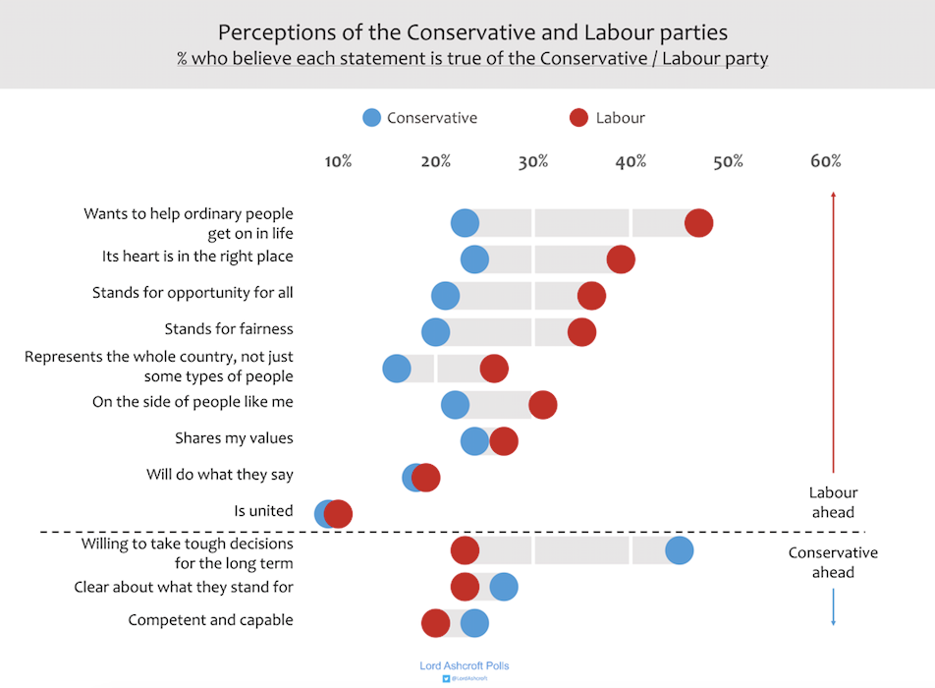¹
Personal Independence Payment (PIP)⁶
PIP is a new and more focussed benefit that provides non-means tested, non-contributory, tax-free support for people with disabilities who need it most and contributes to the extra costs such people face to help them lead full, active and independent lives. The PIP assessment considers the overall impact of a claimant’s health condition or impairment on their functional ability, rather than focusing on a particular diagnosis. It is available to individuals regardless of their work, education or training status. PIP was developed through extensive consultation with experts in disability and engagement with stakeholders, including people with disabilities and their representative organisations.
Spending for the demand-led, extra costs disability benefits – PIP, Disability Living Allowance and Attendance Allowance – has risen by £5.4 billion since 2010 and is at a record high this year of £24.9 billion. And spending on these benefits will be higher every year to 2022 than it was in 2010.
Nearly 1.8 million people are now in receipt of PIP and more support is now going to those who need it the most – overall, 30 per cent of claimants are receiving the highest level of support under PIP compared to 15 per cent of working age claimants under the previous system.
Disability Hate Crime
The number of disability hate crimes more than doubled in just two years, from 1,531 in 2014-15 to 3,079 in 2016-17.
What Our Manifesto Said
“We will push forward with our plan for tackling hate crime committed on the basis of religion, disability, sexual orientation or transgender identity.” (p.44)
“We will also work to help those groups who have in the past found it difficult to get employment, by incentivising employers to take them on. So for businesses employing former wards of the care system, someone with a disability, those with chronic mental health problems, those who have committed a crime but who have repaid their debt to society, and those who have been unemployed for over a year, we will offer a holiday on their employers’ National Insurance Contributions for a full year.” (p.54)
“The disability gap
“We will build on the proud Conservative record in supporting those with disabilities, including the landmark Disability Discrimination Act of 1995. We want to see attitudes to disability shift as they have for race, gender and sexuality in recent years: it should be completely unacceptable for people with disabilities to be treated negatively.
“We will get 1 million more people with disabilities into employment over the next ten years. We will harness the opportunities of flexible working and the digital economy to generate jobs for those whose disabilities make traditional work difficult. We will give employers the advice and support they need to hire and retain disabled people and those with health conditions. We will continue to ensure a sustainable welfare system, with help targeted at those who need it most. We will legislate to give unemployed disabled claimants or those with a health condition personalised and tailored employment support.
“We believe that where you live, shop, go out, travel or park your car should not be determined by your disability. So we will review disabled people’s access and amend regulations if necessary to improve disabled access to licensed premises, parking and housing. We will work with providers of everyday essential services, like energy and telecoms, to reduce the extra costs that disability can incur.” (pp.57-58)
“We have a specific task to improve standards of care for those with learning disabilities and autism. We will work to reduce stigma and discrimination and implement in full the Transforming Care Programme.” (p.70)
Endnotes

For details of work in Scotland, Wales and Northern Ireland, see endnotes 1 and 6.
Progress on the UK’s vision to build a society which is fully inclusive of disabled people: letter from the Minister for Disabled People, Health and Work, Department for Work and Pensions, 3 October 2018: link
Conservative values summary, Conservative Policy Forum, 17 November 2017: link
Lord Ashcroft: The Two Divides – Austerity, Brexit and the problem of building a winning coalition, Conservative Home, 30 September 2018: link
Inclusive Transport Strategy, Department for Transport, 25 July 2018: link
Improving lives: the future of work, health and disability, Department for Work and Pensions, 30 November 2017: link
Purple Tuesday: link
Disability Confident employer scheme and guidance, Department for Work and Pensions, 2 November 2016: link
AT Scale: link
New Inclusive Education Initiative for Children with Disabilities announced by DFID, Norad, and the World Bank, The World Bank, 26 July 2018: link
Concluding observations on the initial report of the United Kingdom of Great Britain and Northern Ireland: initial government response, Department for Work and Pensions, 3 October 2018: link
Homes not hospitals, NHS England: link
Oral Answers to Questions: Work and Pensions, Hansard, 21 May 2018: link
Global Disability Summit 2018, Department for International Development: link
Disabled children hate crime reports increasing, BBC News, 15 October 2017: link

